## BCD configuration

Enbale the debug

*bcdedit /store e:\efiesp\efi\microsoft\boot\bcd /set {default} debug yes*

Configure host IP, port and Key. Host IP address can be set to 1.2.3.4, in that case, the /autodebug parameter needs to be used in virteth.exe. But auto debug does not work quite well for Win10 device in my test. Host IP can also be set in zFeedbackHub app of the device.

*bcdedit /store e:\efiesp\efi\microsoft\boot\bcd /dbgsettings net hostip:10.168.52.144 port:50000 key:1.2.3.4*

If dbgtransport or kerneldebugtype is set, delete it.

*bcdedit /store e:\efiesp\efi\microsoft\boot\bcd /deletevalue {default} dbgtransport*

*bcdedit /store e:\efiesp\efi\microsoft\boot\bcd /deletevalue {default} kerneldebugtype*

## PC setup

Install the KDBG Connectivity package, WP8KDConn.msi(Included in the IHV tools folder of WPAK), which contains the following components:

* Virtual Ethernet tool (VirtEth.exe)
* Virtual network driver (the Virtual PC 2007 filter, VmNetSrv), which is required for the Virtual Ethernet tool unless Virtual PC 2007 is already installed; the user will be prompted to install two unsigned drivers. The testsigning should be opened in 64 bit system.
* USB serial drivers (usb2ethernet and usbcompcom)
* USB debugger drivers (usb2dbg); the user will be prompted to install one signed driver.

The virtual network driver is installed in the *%ProgramFiles%\Microsoft Virtual PC\Utility\VMNetSrv* (or *%ProgramFiles(x86)%\Microsoft Virtual PC\Utility\VMNetSrv* for a 64-bit OS) directory.

The other three components are installed in the *%ProgramFiles%\Microsoft Windows Phone 8 KDBG Connectivity* (or *%ProgramFiles(x86)%\Microsoft Windows Phone 8 KDBG Connectivity* for a 64-bit OS) directory tree, with the virtual Ethernet tool in the bin subdirectory, the USB serial drivers in the drivers\Usb2Eth subdirectory, and the USB debugger drivers in the drivers\Usb2Dbg subdirectory.

Connect the device to the PC, the device can be seen in device manager.

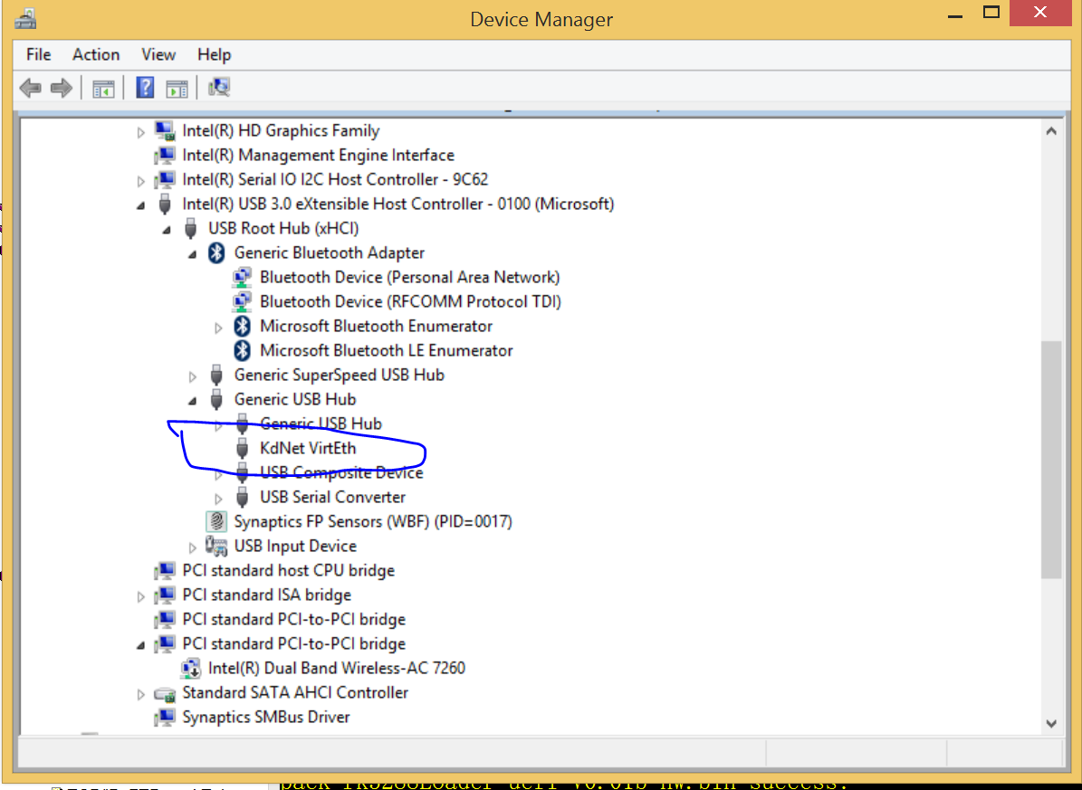

Running Virtual Ethernet

Before connecting any devices or powering on connected devices, first launch VirtEth.exe. This will open a VirtEth console window. Closing this command window will close VirtEth.

On 32-bit operating systems, VirtEth is installed in C:\Program Files\Microsoft Windows Phone 8 KDBG Connectivity\bin. On 64-bit operating systems, it is installed in C:\Program Files (x86)\Microsoft Windows Phone 8 KDBG Connectivity\bin.

After the VirtEth command window is running, connect the phone. When the phone is connected, you will see lines of output in that include the MAC address and IP address of the phone. Note the 12-digit device MAC address and the IP address from the VirtEth console window; these addresses can be used as a parameter for the Open-Device command to establish a TShell connection with the device.

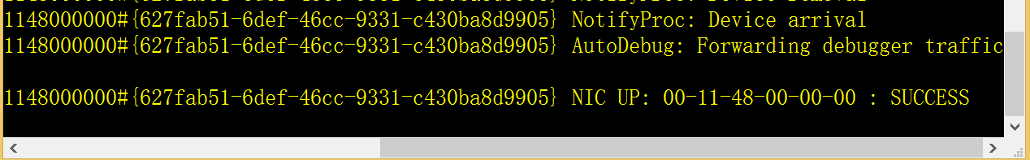

|  |
| --- |
| If you have more than one network adapter in your host computer, you need to modify your network connection settings. Otherwise, you will see an error message similar to the following when you start VirtEth.  *FATAL ERROR: More than one VMNet ports available.*  *Please open Network Connections and make sure that*  *"Virtual Machine Network Services" is bound to one and only one physical NIC.* |

Go to Control Panel > Network and Internet > Network and Sharing Center.

For each network connection that you are not using, click the connection, and then click Properties. Uncheck Virtual Machine Network Services.

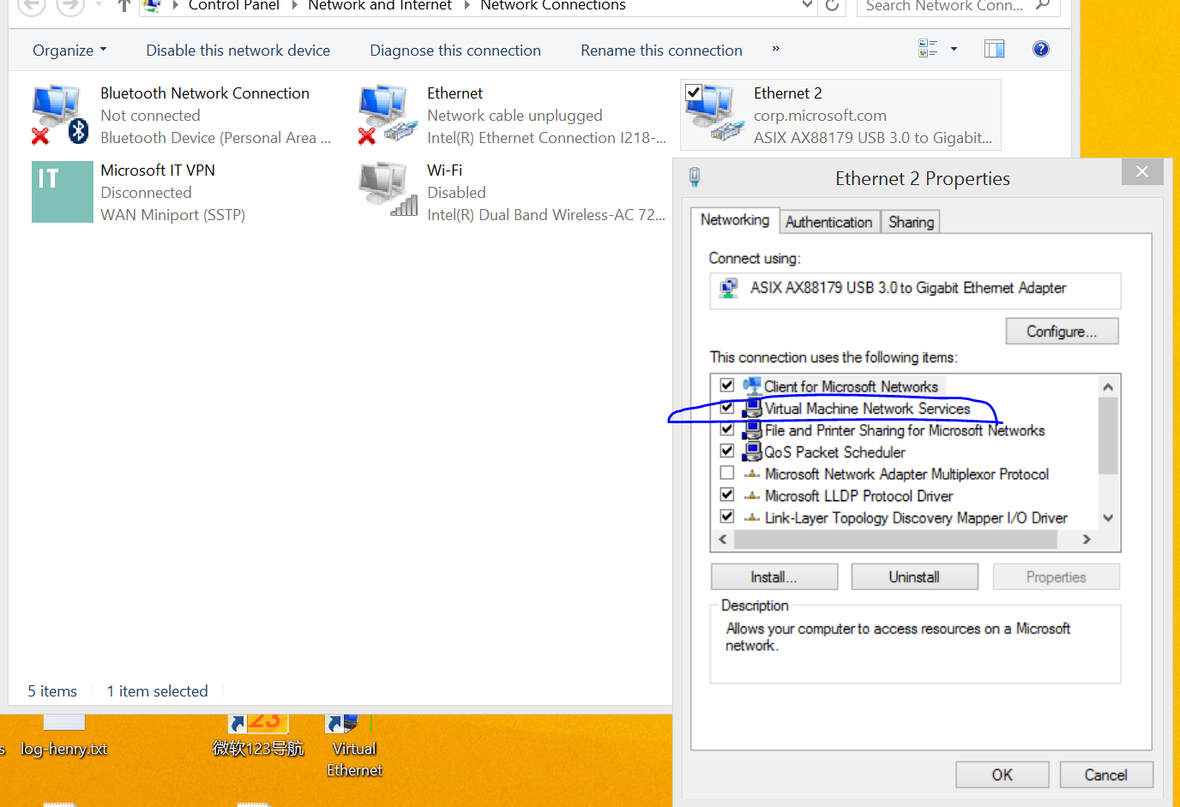

For Win10 PC side configuration is different.

1 Remove WP8KDConn if installed.

2 Install Hyper-V: go to "Control Panel\All Control Panel Items\Programs and Features", select on left side "Turn Windows features on or off". Then select Hyper-V feature and hit OK.

If failed to enable these feature, enable virtualization in BIOS and then try again.

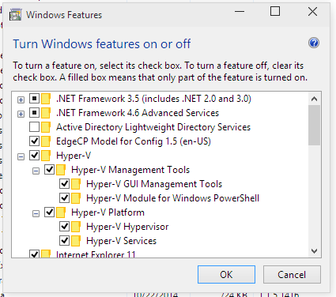

3 After reboot run Hyper-V manager and on left side select Virtual Switch Manager, configure external switch on physical network which should be used for network bridging

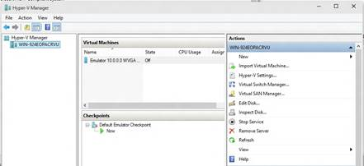

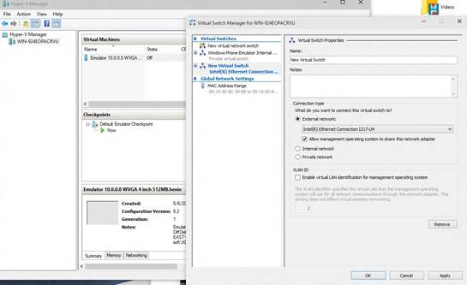

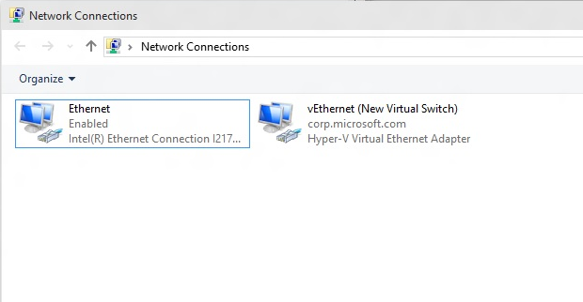

4 Run virteth.exe, and connect windbg. Version 3.5.2.

\\winphonelabs\securestorage\Blue\Project\EngineeringSystems\Technologies\TDX\VirtEth

